

Game title

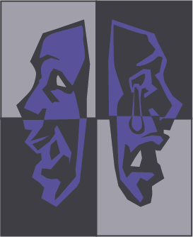

MASKED PRODUCTIONS

**Kahali Griffin, Luke Herron, Sophia Harper, Mark Thomas Gyure, Jacob Stoedter**

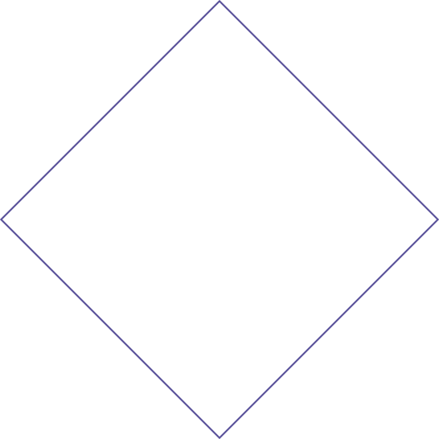

Table of Contents

Placeholder……………………………………………………3

Placeholder……………………………………………………4

Placeholder……………………………………………………6Placeholder……………………………………………………7

Placeholder…………………………………………………...11

Placeholder…………………………………………………...13

Placeholder…………………………………………………...19

Team Breakdown

Text text text text text text text text text text text text text text text text text text text text text text Text text text text text text text text text text text text text text text text text text text text

* Text
* Text
* Text

Placeholder

Section 1: Placeholder

Text text text text text text text text text text text text

text text text text text text text text text text

Text text text text text text text text text text text

text text text text text

=

Section 2: Placeholder

Text text text text text text text text text text text text

text text text text text text text text text text

Text text text text text text text text text text text

text text text text text

* Text text text text text text
* Text text
* Text text text text text text text text